Welcome to the second half of Spring Term! During this half of the spring term, our topics include Touch/World Book Day/Spring and Growth, and much more! We include a nursery rhyme and shape of the week in our weekly plan. We will be doing some Mother’s Day, and Easter related activities! We will continue to go outside in all weathers, so please ensure your children bring along a (named) warm and waterproof coat and hat and gloves when needed.
Helping in the Group Thank you to those who have already helped on our parent/helpers’ rota. We and the children really appreciate it! The new rota is on the parent table so please sign up to come in if you have the opportunity. If you are new to the pre-school it would be lovely if you are able to help out later on in the year when your child has had a chance to settle fully. _______________________________
Who is collecting your child today? Please continue to inform us of the telephone number and full name of the person who is picking up your child from their session. Please put these details on our notification sheet in the hall. They must be over the age of 18 and carry some form of identification.

If your collection arrangements change during a session please telephone us immediately to provide the details. _______________________________
World Book Day 7 March 2019 Your children can celebrate World Book Day with us by coming in all week dressed as their favourite book character, why not bring their favourite book along to share with their friends too?
Parents Evening – Wednesday 27th February If you would like to attend and haven’t already done so, please book a slot to meet with your child’s key person to discuss their progress at Teddy Bears. Head of Year R at Poulner Infants, Julie Smith, will also be there at 8.10pm to talk about school readiness (and answer any questions).
_________________________________
Duck Race 2019 – Date for your diary! Sunday 19th May 2019, more on this to follow.

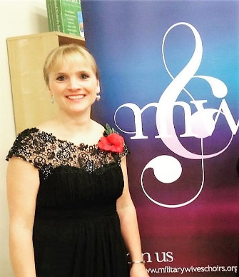
Bovington Military Wives Choir Concert Fundraiser on Saturday 16th March featuring our own ‘Helen Pugh’ It is not too late to get your tickets, which have now gone on sale to the general public. We are also holding a raffle on the night, and would very much appreciate any donations of chocolate and/or wine for our hamper prize!
_________________________________
Healthy Eating at Teddy Bears Please can we remind you that Teddy Bears Pre-School promotes healthy eating, and is a “NUT FREE ZONE”. Please continue to provide your child with a healthy variety of food, cut into child friendly size. Please ensure grapes/tomatoes etc are cut lengthways to avoid the possibility of choking. Please can we remind you that items that may contain nuts, sweets, chocolate and chocolate covered items are not allowed in the pre-school.
_________________________________
Walk Week
Subject to the weather, we hope to take
the children on a walk on Tuesday 19th March and Thursday 21st March.
_________________________________
Illness Please advise us if your child is going to be off due to illness, and the reason. Please keep them off until fully recovered.
Is it ok to go to Pre-school?
Below is a link to a guide of common illnesses that children can often suffer with and the steps of what to do in order to treat the child.
http://what0-18.nhs.uk/parentscarers/child-unwell-ok-go-nurseryschool
_________________________________
Snow days and Emergency Closure If Teddy Bears has to close due to the above we will do our best to offer you a free alternative session. If we do have a snow day, please check our facebook page and your emails regularly and we will send a message out as soon as the decision to close is made.
_________________________________
Sharing special skills If you have a hobby, profession or talent you would like to share with the children, please see a member of staff to arrange to come in and share it with us!
Have a wonderful half term!

