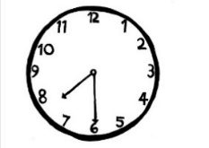
Welcome to the Spring Term 2020! Special topics and interests during this first half of the Spring term will be exploring winter and recapping Christmas and New Year, we will be looking closely at ourselves and our senses and other people, and learning all about what our bodies can do. Please see our weekly plans (sent out at the end of the previous week) that cover in detail what your children will be doing in their sessions. We will continue to go outside in all weathers, so please ensure your children bring along a (named) warm and waterproof coat and hat and gloves when needed. If your child has borrowed any clothes from Teddy Bears, please return them as they are in constant demand. Finally, the staff would like to say a big thank you all for your wonderful cards and gifts at the end of last term!
Dropping off and collecting your child
Please ensure that you collect your child on time. If you are late, this impacts on our next session’s child numbers.
_______________________________
Child Influenza Immunization
All children aged 2, 3 and 4 can get a flu vaccine (a nasal spray) at their GP Practice. Please contact them directly if this is something which you feel would benefit your child.

Teddy Bears Parents Evening We will be holding a parents evening in the second half of the Spring term, further details to come nearer the time.
_________________________________
Healthy Eating at Teddy Bears Please can we remind you that Teddy Bears Pre-School promotes healthy eating, and is a “NUT FREE ZONE”. Please continue to provide your child with a healthy variety of food, cut into child friendly size. Please ensure grapes/tomatoes etc are cut lengthways to avoid the possibility of choking. Please can we remind you that sweets, chocolate and chocolate covered items are not allowed in the pre-school. _________________________________Parents and Carers Personal Information
Have you moved house, or changed telephone number recently? Please update us of any changes, so that we can get hold of you during a session in case your child is taken ill. Please always leave your mobile telephone ON when your child is with us. Please write down your new details and hand them to a member of staff, or you can email them through to our Administrator, Sally.

Teddy Bears Uniform A reminder that Teddy Bears uniform is available. T-Shirts £9 and Sweatshirts £10. We also have some second hand items at half price.
_________________________________
Reminder of charging policy and Extra Sessions As a charity, we are unable to offer reduced rates for holidays taken. If your child is taken out of pre-school to go on holiday or due to illness (unless in exceptional circumstances), the sessions they miss are billed as normal. We may be able to accommodate extra sessions if required, these will be charged at our normal hourly rate of £4.50 per hour or may be covered by EYE funding if your balance of hours allows.
_________________________________
Snow days and Emergency closure If Teddy Bears has to close due to the above we will do our best to offer you an alternative session. If we do have a snow day, please regularly check our facebook page and your emails; we will send a message out as soon as the decision to close is made.
_________________________________
Phonics, letter sounds and formation
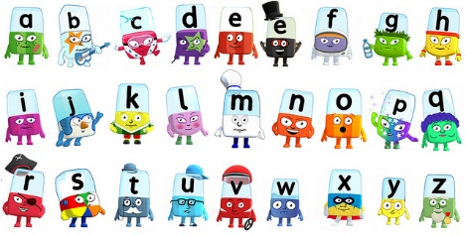
To help your child learn the pure letter sounds and phonics, see the CBeebies website link ‘Alphablocks’.

Sharing special skills If you have a hobby, profession or talent you would like to share with the children, please see a member of staff to arrange to come in and share it with us!

Have a wonderful half term!

Spring term
Spring Term from Monday 6th January 2020 to Friday 3rd April 2020
Inset Day 3 – Friday 14th February 2020 (Teddy Bears Closed)
Spring Half Term Holiday from Monday 17th February 2020 to Friday 21st February 2020
Easter Holiday from Monday 6th April 2020 to Friday 17th April 2020

Summer term
Summer Term from Monday 20th April 2020 to Wednesday 22nd July 2020
Bank Holiday Friday 8th May 2020
Summer Half Term Holiday from Monday 25th May 2020 to Friday 29th May 2020
Inset Day 4 – Monday 1st June 2020 (Teddy Bears Closed)
Inset Day 5 – Friday 10th July 2020 (Teddy Bears Closed)
Summer Holiday from Thursday 23rd July 2020

